Chapter 2, Solution 57

Find R_{eq} and I in the circuit of Fig. 2.121.
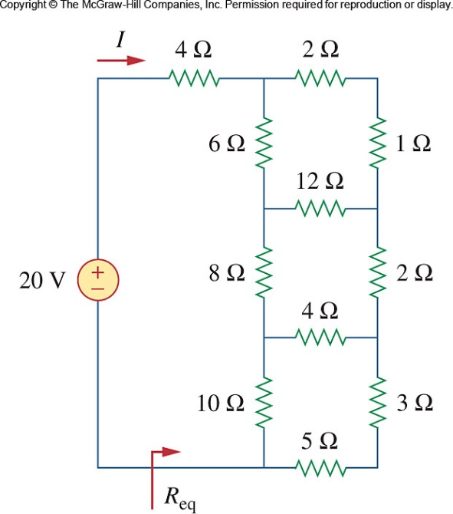

Figure 2.121
For Prob. 2.57.

Solution

4 Ω

10 Ω

28 Ω

1 Ω

18 Ω

2 Ω

27 Ω

14 Ω

7 Ω

36 Ω

bb

a

f

e

d

c

R_{ab} =
R_{ac} = 216/(8) = 27Ω, R_{bc} = 36 Ω
R_{de} =
R_{ef} = 56/(4) = 14Ω, R_{df} = 56/(2) = 28 Ω

Combining resistors in parallel,

4 Ω

7.568 Ω

5.868 Ω

18 Ω

14 Ω

2.7 Ω

14 Ω

7.568 Ω

4 Ω

1.829 Ω

3.977 Ω

0.5964 Ω

12.21 Ω
i = 20/(R_{eq}) = 1.64 A

